
NAME: RACHITHA.R
REG-NO: 192421058
SUBJECT: COMPUTER VISION FOR IMAGE SEGMENTATION
SUBJECT-CODE: ITA0528
DATE: 28.02.2026
EXPERIMENT -11
CODE:
import cv2
img = cv2.imread("sample.jpg")
rotated = cv2.rotate(img, cv2.ROTATE_180)
cv2.imshow("Original", img)
cv2.imshow("180 Degree Rotated", rotated)
cv2.waitKey(0)
cv2.destroyAllWindows()
Input:
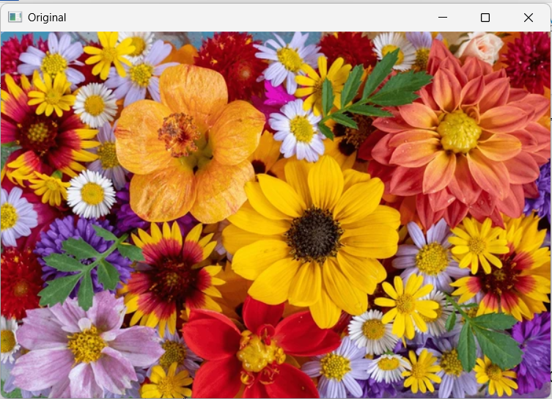
Output:
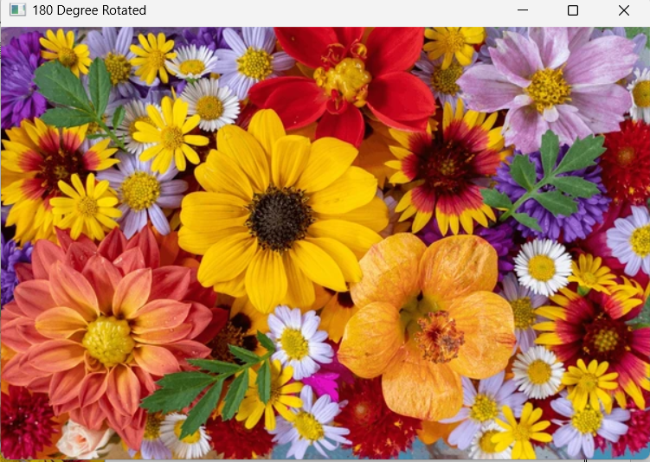
EXPERIMENT – 12
Code:
import cv2
img = cv2.imread("sample.jpg")
rotated = cv2.rotate(img, cv2.ROTATE_90_COUNTERCLOCKWISE)
cv2.imshow("Original", img)
cv2.imshow("270 Degree Rotated", rotated)
cv2.waitKey(0)
cv2.destroyAllWindows()
Input:

Output:
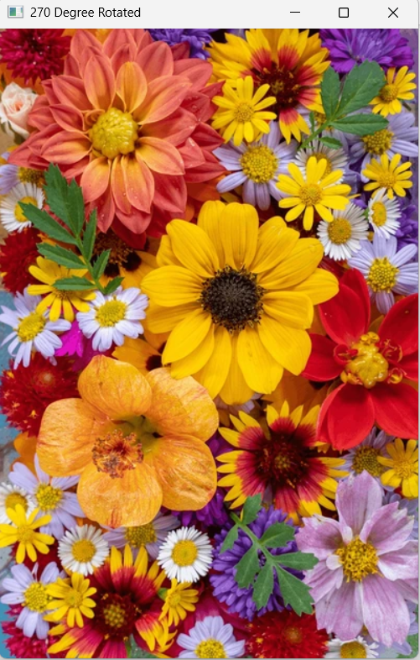
EXPERIMENT – 13
Code:
import cv2
import numpy as np
img = cv2.imread("sample.jpg")
rows, cols, ch = img.shape
pts1 = np.float32([[50,50],[200,50],[50,200]])
pts2 = np.float32([[10,100],[200,50],[100,250]])
matrix = cv2.getAffineTransform(pts1, pts2)
result = cv2.warpAffine(img, matrix, (cols, rows))
cv2.imshow("Original", img)
cv2.imshow("Affine Transform", result)
cv2.waitKey(0)
cv2.destroyAllWindows()
Input:
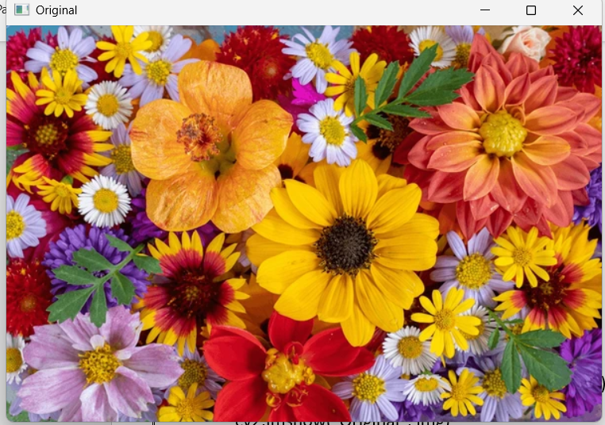
Output:
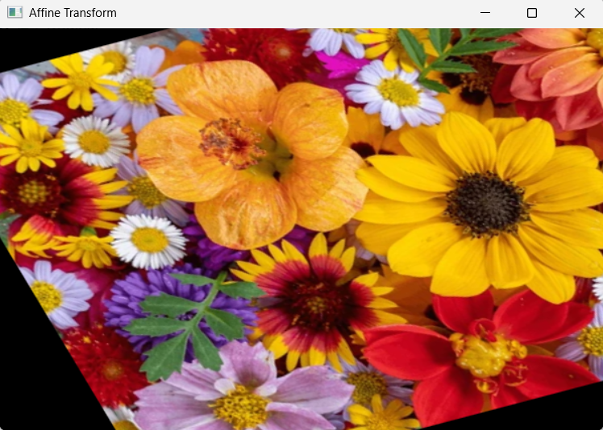

EXPERIMENT – 14
Code:
import cv2
import numpy as np
img = cv2.imread("sample.jpg")
rows, cols, ch = img.shape
pts1 = np.float32([[50,50],[300,50],[50,300],[300,300]])
pts2 = np.float32([[0,0],[400,0],[0,400],[400,400]])
matrix = cv2.getPerspectiveTransform(pts1, pts2)
result = cv2.warpPerspective(img, matrix, (400,400))
cv2.imshow("Original", img)
cv2.imshow("Perspective Transform", result)
cv2.waitKey(0)
cv2.destroyAllWindows()
Input:

Output:
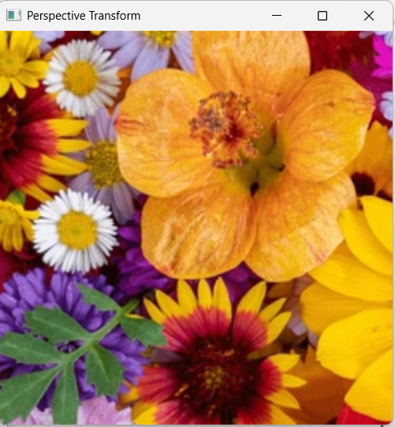

EXPERIMENT – 15
Code:
import cv2
import numpy as np
img = cv2.imread("sample.jpg")
gray = cv2.cvtColor(img, cv2.COLOR_BGR2GRAY)
gray = np.float32(gray)
corners = cv2.cornerHarris(gray, 2, 3, 0.04)
img[corners > 0.01 * corners.max()] = [0,0,255]
cv2.imshow("Harris Corners", img)
cv2.waitKey(0)
cv2.destroyAllWindows()
Output:
